

**CISC3015 - Data and Information Visualization (2024-1 001)**

**Preliminary Project Proposal**

**Student:** Tailine Juliana dos Santos Nonato

**Student ID:** DC427182

## 1.1) Region

Brazil

## 1.2) Domain category

Public social politics; basic educational system

## 2) Main question

How does the behavior of grades in Mathematics change over Brazilian states?

## 3) Datasets

* Link 1: <https://www.gov.br/inep/pt-br/areas-de-atuacao/avaliacao-e-exames-educacionais/saeb/resultados>
* Link 2: <https://download.inep.gov.br/microdados/microdados_saeb_2021_ensino_fundamental_e_medio.zip>

## 4) Addressing the research question

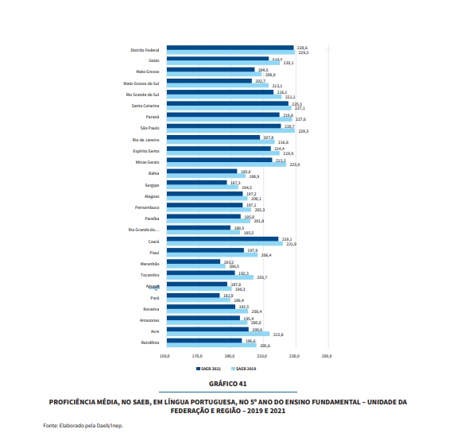

* The chart shows the mean for grades in Portuguese Language for two different years for each state.
* Link: <https://download.inep.gov.br/educacao_basica/saeb/2021/resultados/relatorio_de_resultados_do_saeb_2021_volume_1.pdf>

## 5) Justification for the theme

The data is widely popular for researchers in Brazil that focus on education as it is one of the largest initiatives to measure the quality of basic education in Brazil. Since this is the area I have been interested in for a long time, my graduation project is related to Multilevel Regression Analysis on this same data. Frequently, I wonder how many other better ways of visualizing this kind of data there is.